

December 2021 Workshops
620 N. Broadway, Pittsburg, KS 620-240-0165

ArtForms Gallery is a co-op of artists offering monthly workshops ranging from acrylic painting, watercolor, glass fusing, pottery, metalsmithing, jewelry, textiles, kids’ art and more! All workshops are held at the Gallery unless otherwise noted. Please call Artforms Gallery to register for any artist’s workshop. 620-240-0165
Refunds/Cancellations—Decisions regarding refunds and cancellations are determined by the artist leading the workshop. You can find individual contact information for each artist on the “Artists” page of our website, or just call the Gallery and we’ll get you in touch.
Website: www.artforms-gallery.com
Facebook: ArtFormsGallery620/

ArtForms Gallery artists are doing our part in maintaining a clean and safe environment for you to shop or take a workshop. At the time of this publication, we are still recommending wearing masks when shopping and requiring them during workshops. Please watch for announcements or call the Gallery for updates as these guidelines may be adjusted according to changing health conditions in our community. We look forward to seeing you soon!

Give the gift of local art with an ArtForms Gallery Gift Card!
Gift cards may be purchased in any amount and do not expire.

To check the balance of your Gift Card online:
https://squareup.com/gift/46K96BF2TK6W7/check-balance

Are you having family returning home for the Holidays? Plan a special workshop with one of our artists just for your family and/or friends!
Holiday Open House!
Join the ArtForms Gallery artists
during our Holiday Open House!
Saturday, December 4
5:00 p.m. – 8:00 p.m.

Art Exploration! Free! Free! Free! Artists: Pat Glick and Laura Wright
Are you looking for camaraderie while exploring your artistic side? Join Gallery artists Pat Glick and Laura Wright every Tuesday afternoon for a fun time working on your own project or art! Bring your materials and create with us for free!
- Tuesdays, December 7, 14, 21, 28 | 12:30 – 2:30 p.m.
- Workshop Fee: FREE~FREE~FREE!!!

Weekly Beginning Painting Instruction Artists: Laura Wright and Pat Glick

Join Pat and Laura on Tuesdays 3:30 – 5:30 p.m. for beginning painting instruction! Materials and supplies will be provided. For a nominal fee of $15 for each session, you will learn basic brush strokes, shading, blending, and more!
- Tuesdays, December 7, 14, 21, 28 | 3:30 – 5:30 p.m.
- Workshop Fee: $15 per session, payable at time of registration each week to reserve a spot
- Ages: 11 and older

LET'S MAKE A SNOWMAN⛄ Artist: Debbie Southard
If the snow isn’t already flying this winter, it soon will! Let's get together and make a SNOWMAN (fluid acrylic paint-style) for the cold weather season! This is a really fun and loose swipe technique. No experience is necessary, so come for the fun. This will make a great holiday gift!
⛄ ⛄ ⛄ ⛄ ⛄ ⛄ ⛄ ⛄ ⛄ ⛄ ⛄ ⛄
- Saturday, November 27 | 2:00 – 4:00 p.m.
- Workshop fee: $35 per person, payable at time of registration
- Class size: 10
- Ages: 16 and older

Kitchen Helpers in Ceramics Artist: Daria Claiborne
You have a choice! From a slab of clay, you may create a pitcher, butter dish, or a set of salt and pepper shakers. You can even go for the gust and make two of the items…or even all three! As always, all supplies are provided. A choice of glaze colors and different embellishments are up to you to decide. Bring your creativity and willingness to play in the clay!
- Sunday, December 5 | 1:00 – 4:00 p.m. (must be finished in time allotted)
- Workshop fee: $40 for one item; $60 for two items; $75 for all three, payable at time of registration
- Class size: 10
- Ages: 16 and older

Friday Night Dyes and Ties Artist: Jordaine Pollard
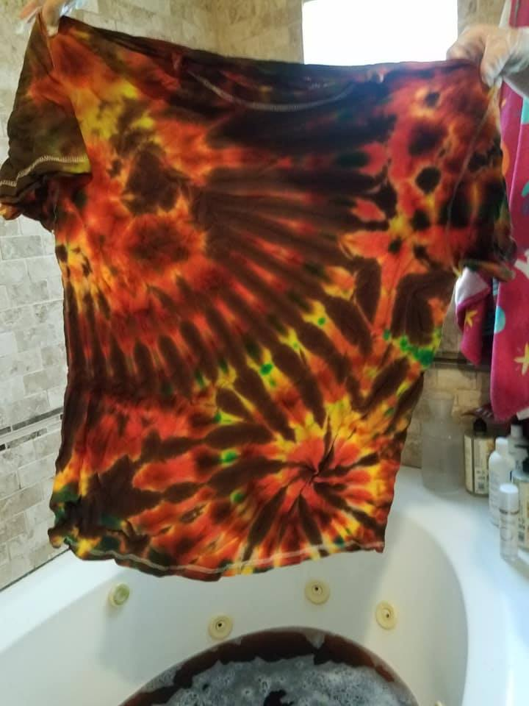
Get your Dye and Tie going this month! Learn unique folding and saturation for high quality wearable art. Create your own custom piece as Jordaine demonstrates the process. These will make excellent gifts for the hard-to-buy for person on your list!
- Friday, Dec. 10 | 4 p.m. – 6 p.m.
- Workshop fee: $30 for 2 new shirts; payable at time of registration
- Ages: 16 and older
- Class limit: 10
- Upcycling welcome! Bring your own shirt for only $10 per dyed item. Maximum 4 items each person. Please provide the appropriate T-shirt size at the time of registration if you do not bring your own upcycled item!!!

Upcycled Snowmen! Artist: Brenda Hayes
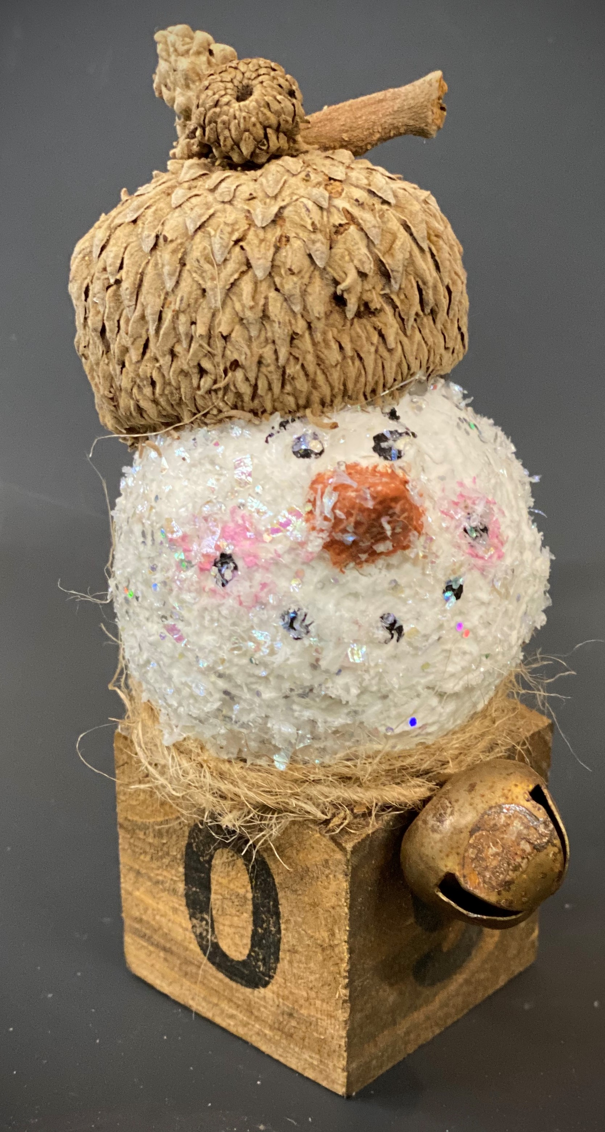
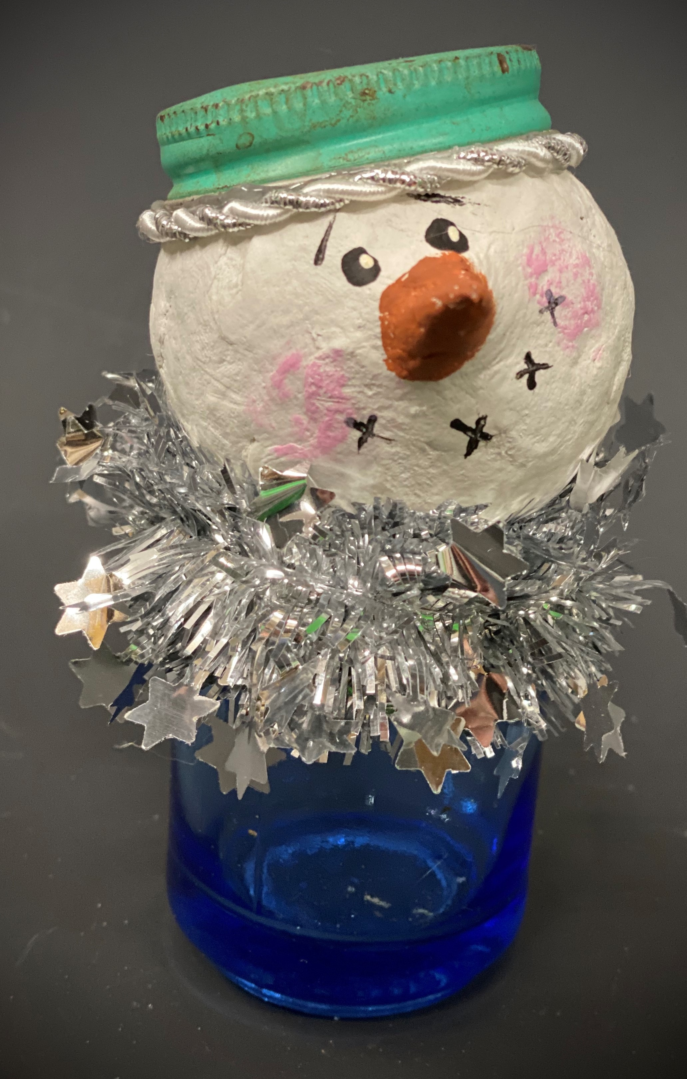
Make your own really creative upcycled snowmen from some of Brenda’s most unique materials collected over time! All supplies are provided as well as step-by-step instruction.

- Sunday, December 12 | 2:00 – 4:00 p.m.
- Workshop fee: $40 per person, payable at time of registration
- Class size: 8
- Ages: 14 and older

Do you recognize the components of these adorable snowmen???

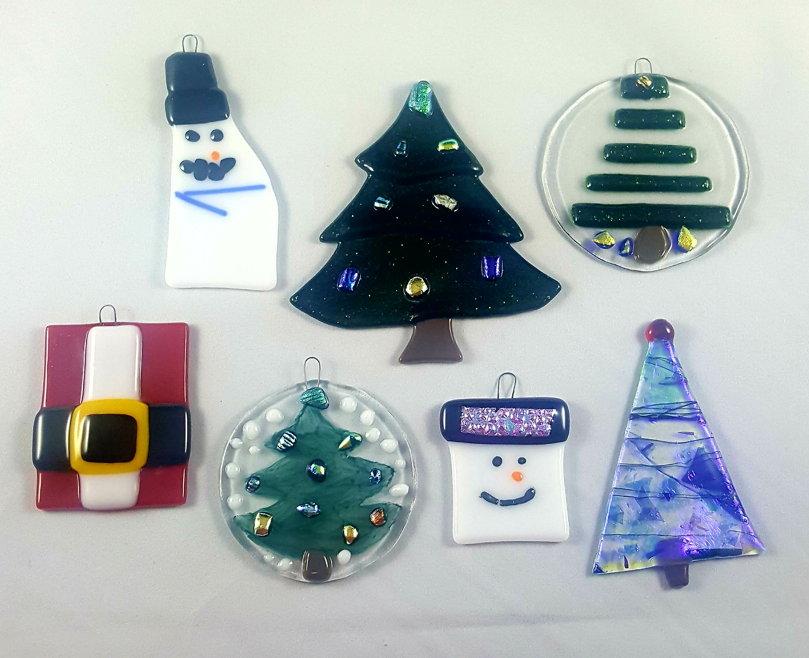
Fused Glass Holiday Ornaments Artist: Dianne Miller
Give your own uniquely handcrafted gifts this season! Join Dianne in this fused glass workshop creating your own glass ornaments! Ornaments make great stocking stuffers or as part of the gift’s packaging. Participants should be able to make 4-6 small ornaments. Basic glass-cutting skills are demonstrated. Individual instruction is provided along with all glass tools and material. After fusing in my home studio, your ornaments will be returned to the Gallery and ready for you to pick up December 22 at the Gallery!
- Saturday, December 18 | 1:00 p.m. – 3:00 p.m.
- Workshop fee: $40 for 4-6 small ornaments; payable at time of registration
- Ages 14 and older
- Class limit: 10

Check our Facebook page during the month as artists may offer “popup” workshops!
ArtForms artists also offer pop-up workshops during the month. Follow the Gallery on its Facebook page and/or its website!
- Facebook: ArtFormsGallery620/
- Website: www.artforms-gallery.com
Do you have a birthday or special occasion to celebrate? Contact the Gallery to book a private party with an ArtForms Gallery artist!
Possibilities include:
- Sip and Paint  - Painting  - Jewelry  - Textiles | - Fused Glass/Stained Glass  - Pottery (ceramic birdhouse, windchime, pitchers)  - Fiber
Have a workshop suggestion or special request for us?
Don’t hesitate to give us a call!


Become a
Gallery Patron
Save 10% on every workshop you take in a 12-month period!!!
Only $40.00


Give the gift of creativity with an
ArtForms Gallery Gift Card or a
Gallery Patron Membership!

