
January 2020 Workshops
620 N. Broadway, Pittsburg, KS 620-240-0165

ArtForms Gallery is a co-op of 22 different artists offering monthly workshops ranging from oil painting, glass fusing, pottery, wood carving, metalsmithing, jewelry, textiles, kids’ art, photography, and more! All workshops are held at the Gallery unless otherwise noted. Please call Artforms Gallery to register for any artist’s workshop. 620-240-0165

Refunds/Cancellations—Decisions regarding refunds and cancellations are determined by the artist leading the workshop. You can find individual contact information for each artist on the “Artists” page of our website, or just call the Gallery and we’ll get you in touch.

Fused Glass Windchimes Artist: Dianne

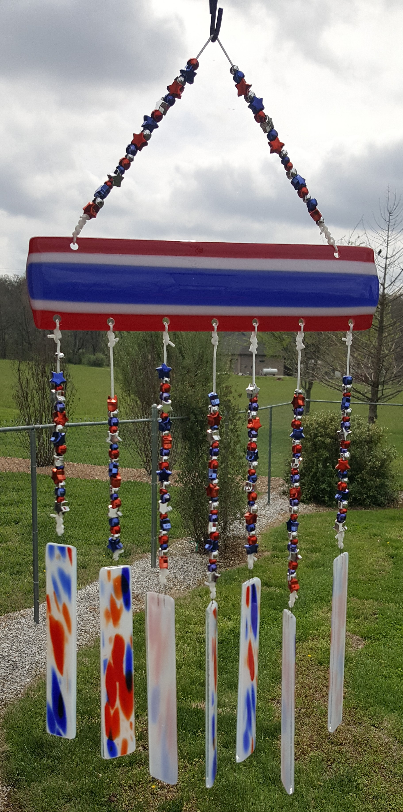
Who doesn't love the sound of a gentle wind tinkling glass? Create your own fused glass windchime and be ready for Spring. Basic glass-cutting instructions and demonstration will be given, so there is no need for experience. Bring your enthusiasm and creativity. Square, rectangular, or circular metal frames will be provided. Workshop fee includes all materials. Please do not wear open-toed shoes when working with glass. (Besides, it will be the middle of January in Kansas!)
- Saturday, January 11 12:00 p.m. – 3:00 p.m.
- Workshop Fee: $50, due at time of registration
- Ages 14 and older
- Class size limited to 10

Snow Scene Painting! Artist: Pat

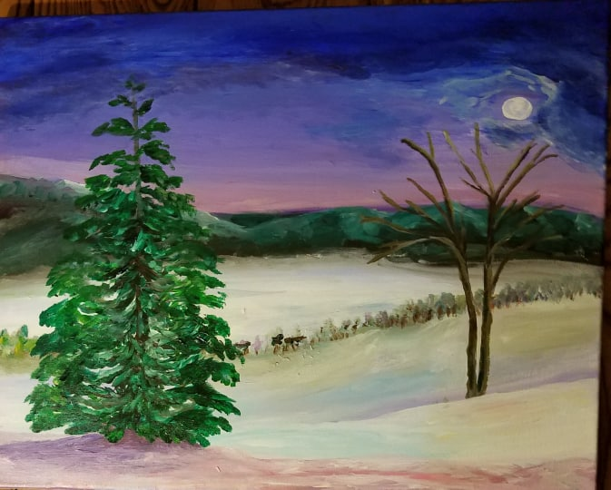

Join artist Pat Glick in painting this moonlit snow scene using acrylic paints. All supplies are provided, including the canvas and instruction as needed. All skill levels welcome.
- Saturday, January 25 1:00 p.m. – 4:00 p.m.
- Workshop fee: $30
- Age group: Adults
- Class size: 8

Art Exploration! Free! Free! Free!
Are you looking for camaraderie while exploring your artistic side? Join Gallery artist Pat Glick every Tuesday afternoon, 1 p.m. – 3 p.m. to explore different art techniques. Pat will lead you through a creative art experience every week. Feel free to bring something you are working on also. We will have opportunities to participate in community activities and charities at times.
Art Exploration is free so you just bring your willingness to try something new in art!

ArtForms artists also offer pop-up workshops during the month. Follow the Gallery on its Facebook page and/or its website!
- Facebook: https://www.facebook.com/ArtFormsGallery620/
- Website: www.artforms-gallery.com

Do you have a birthday or special occasion to celebrate? Contact the Gallery to book a private party with an ArtForms Gallery artist!
Possibilities include:
- Sip and Paint
- Painting
- Jewelry
- Fused Glass
- Pottery (ceramic birdhouse, windchime, pitchers, wheel-throwing)
- Textiles and more!

Have a workshop suggestion or special request for us?
Don’t hesitate to give us a call!


Become a
Gallery Patron
Save 10% on every workshop you take in a 12-month period!!!
Only $40.00


Give the gift of creativity with an
ArtForms Gallery Gift Card or a
Gallery Patron Membership!

