
March 2020 Workshops
620 N. Broadway, Pittsburg, KS 620-240-0165

ArtForms Gallery is a co-op of 22 different artists offering monthly workshops ranging from oil painting, glass fusing, pottery, wood carving, metalsmithing, jewelry, textiles, kids’ art, photography, and more! All workshops are held at the Gallery unless otherwise noted. Please call Artforms Gallery to register for any artist’s workshop. 620-240-0165

Refunds/Cancellations—Decisions regarding refunds and cancellations are determined by the artist leading the workshop. You can find individual contact information for each artist on the “Artists” page of our website, or just call the Gallery and we’ll get you in touch.

POP (Paint on Paper) Gatherings Artist: Nicole
This is a gathering for you who paint with watercolor or those of you who are interested in watercolor painting. This is NOT a workshop, and there is NO workshop fee! Bring your own supplies and a project that you are working on or begin one here. Enjoy camaraderie, encouragement, and a little feedback if you desire. POP Gatherings will be held on the first and third Wednesdays beginning in February and continuing through May

- 1st and 3rd Wednesdays beginning in February through May
- Time: 5:00 p.m. – 6:15 p.m.

Learn to Draw* Artist: Sharon
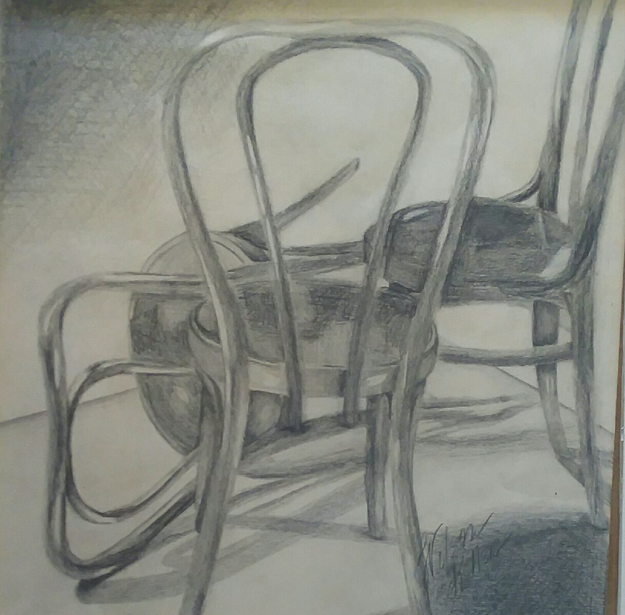
Do you like to draw but would like to improve your skills? This workshop of 6-weeks will focus on a combination of methods that teach drawing from skills you already possess.
Sharon attended Parsons School of Design in New York before graduating from Northeastern State University. She has exhibited in numerous galleries and exhibitions. Don’t miss this opportunity to improve your drawing!
*This workshop began in February and will conclude with sessions March 5 and March 12.
- 6:00 p.m. – 7:30 p.m.

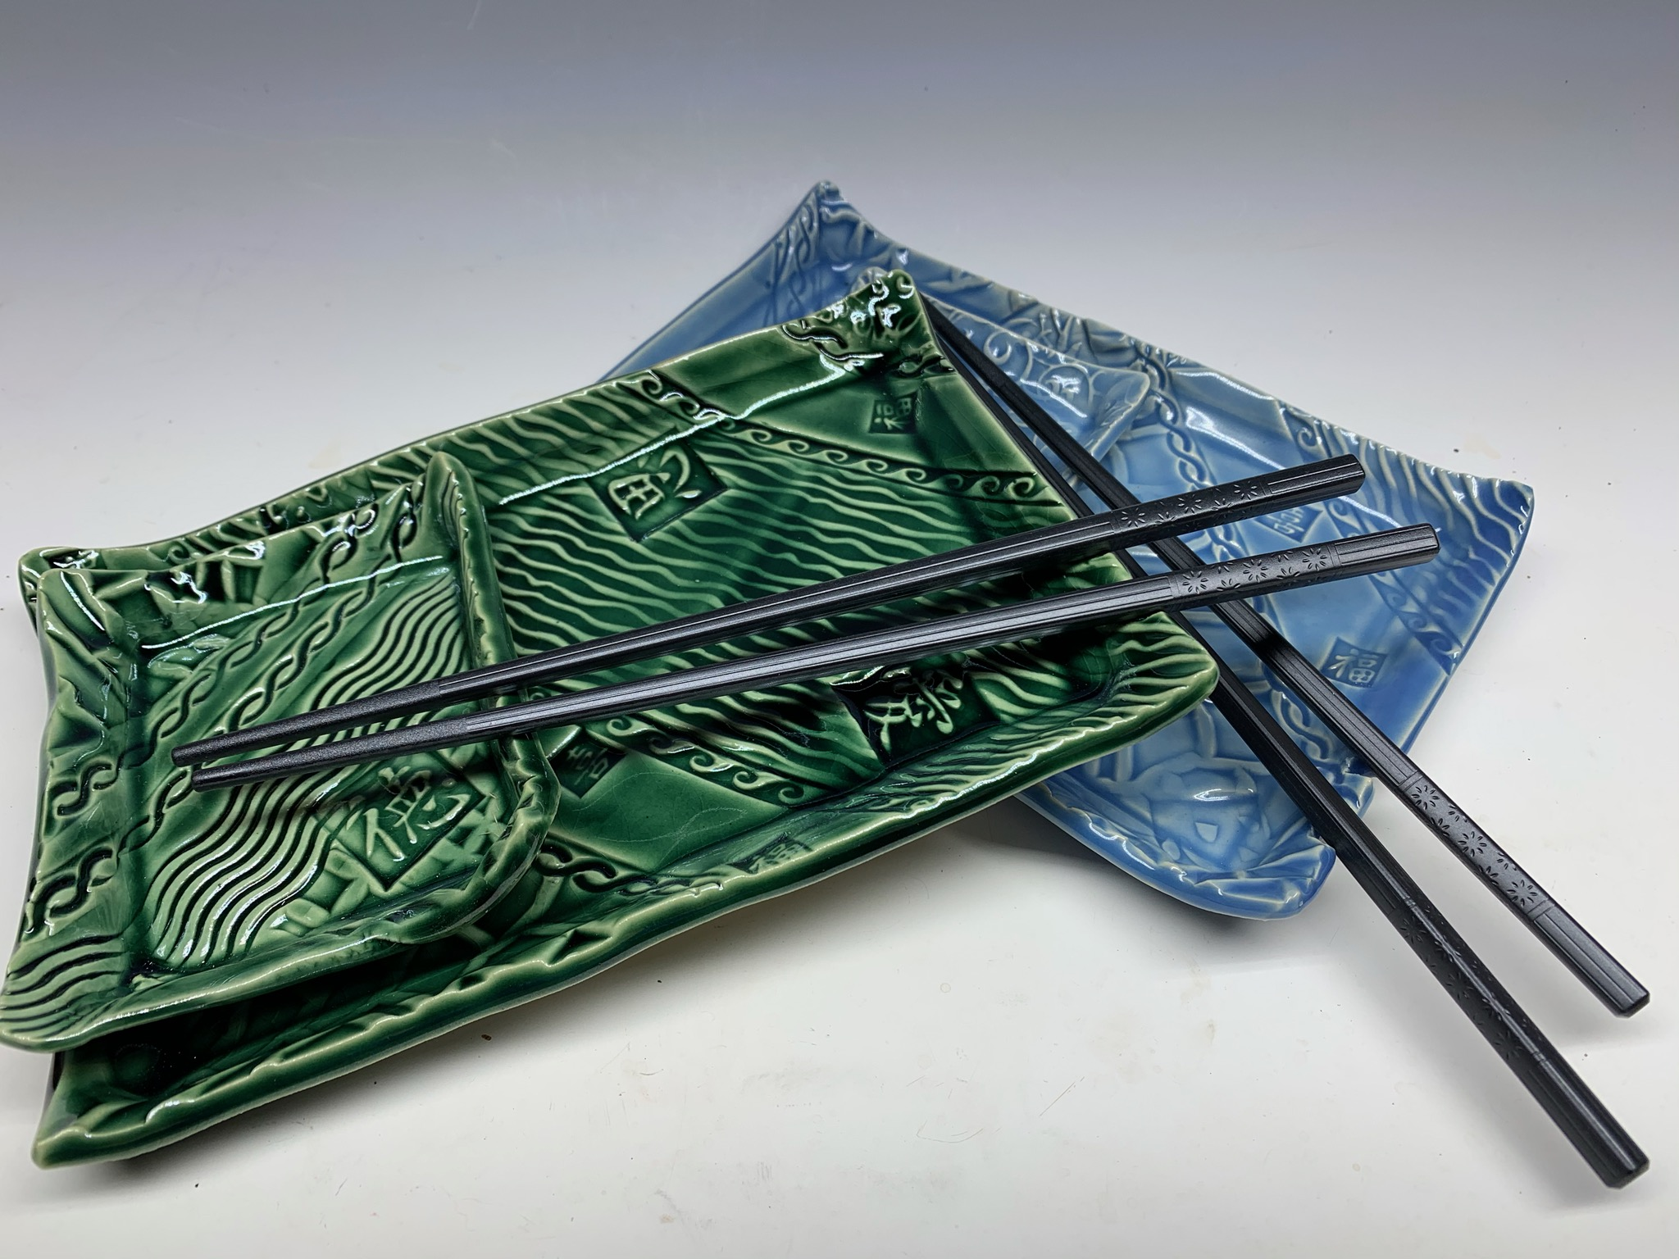
Ceramic Sushi Set Artist: Daria
Do you love getting your hands dirty? Here’s your chance to do so with Daria who will lead you in this hand-built ceramic workshop! She will lead through the process of constructing your own set of sushi dishes. You will use a variety of stamps to texture your design into a slab of clay, and create functional trays for sushi Your pieces will be fired to bisque and then glazed before firing again. Workshop fee includes clay, glaze, and 2 kiln-firings.
- Sunday, March 8 2:00 p.m. – 4:00 p.m.
- Workshop fee: $35, one set; $10 for each additional piece
- Ages: Any age, but under 14 with adult supervision
- Class size: 12 people

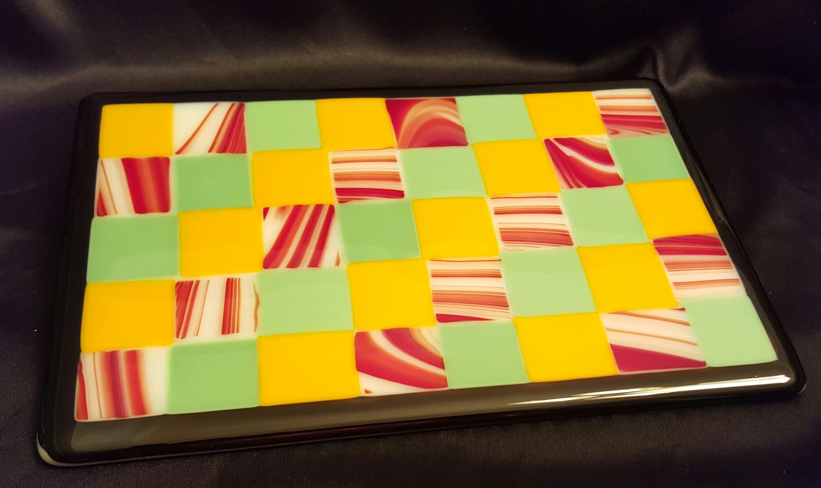
Fused Glass: Small Plate or Bowl! Artist: Dianne
This fused glass workshop features small bowls and plates. Participants will select a ceramic mold to determine the size of the base glass, then select from a variety of fusible glass pieces to design a top layer. After fusing the two layers together, the project will be slumped in the chosen ceramic mold to achieve the shapes of either a small bowl or plate. This workshop involves a variety of glass-cutting techniques which will be demonstrated, so experience is not necessary. Just bring your enthusiasm and creativity! Please do not wear open-toed shoes when working with glass. Workshop fee includes instruction, use of tools, glass, and 2 kiln-firings.
- Saturday, March 14
- 1:00 p.m. – 4:00 p.m.
- Workshop Fee: $50, due at time of registration
- Class size limited to 8
- Ages: 14 and older

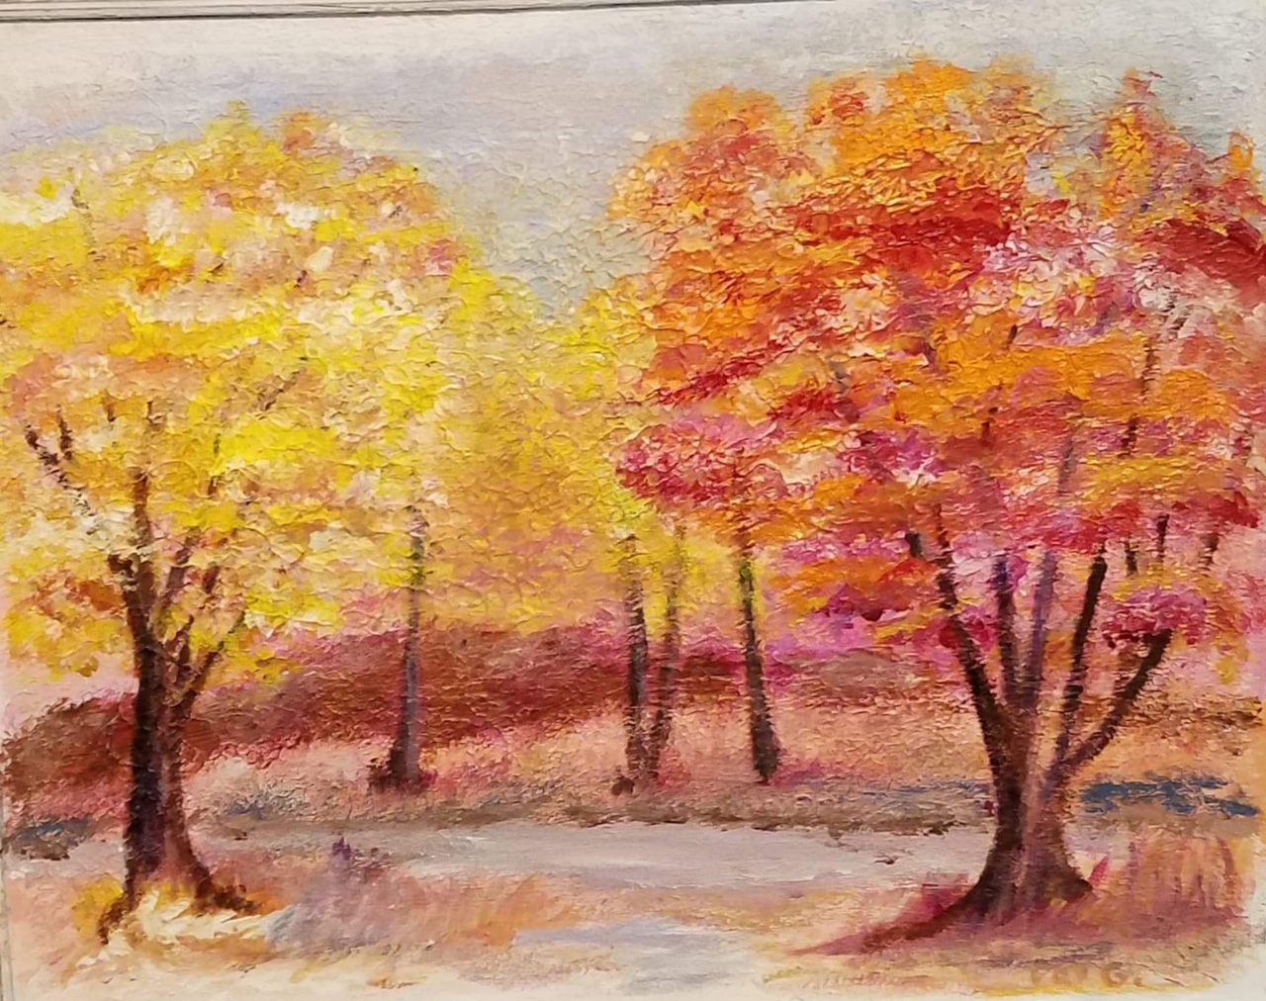
“A Walk in the Woods” Artist: Pat
This workshop will be a chance to learn how to use flexible modelling paste. We will paint using sponges, brushes, and other tools. This technique can be used to recycle an old painting if it is acrylic!

- Sunday, March 22
- 1:00 p.m. – 4:00 p.m.
- Workshop fee: $30, payable at time of registration
- Class size: 8 adults

Relief Carved Green Man Artist: Lanny
In this workshop, you will learn the basic woodcarving cutting strokes using a carving’s bench knife and various chisels to relief carve a Green Man from a roughout in basswood bark. Bring your own tools or purchase tools that day at ArtForms Gallery.
- Saturday, March 28
- 10:00 a.m. — 2:00 p.m.
- Workshop fee: $40, payable at time of registration
- Class size: 8
- Ages: 18 and older

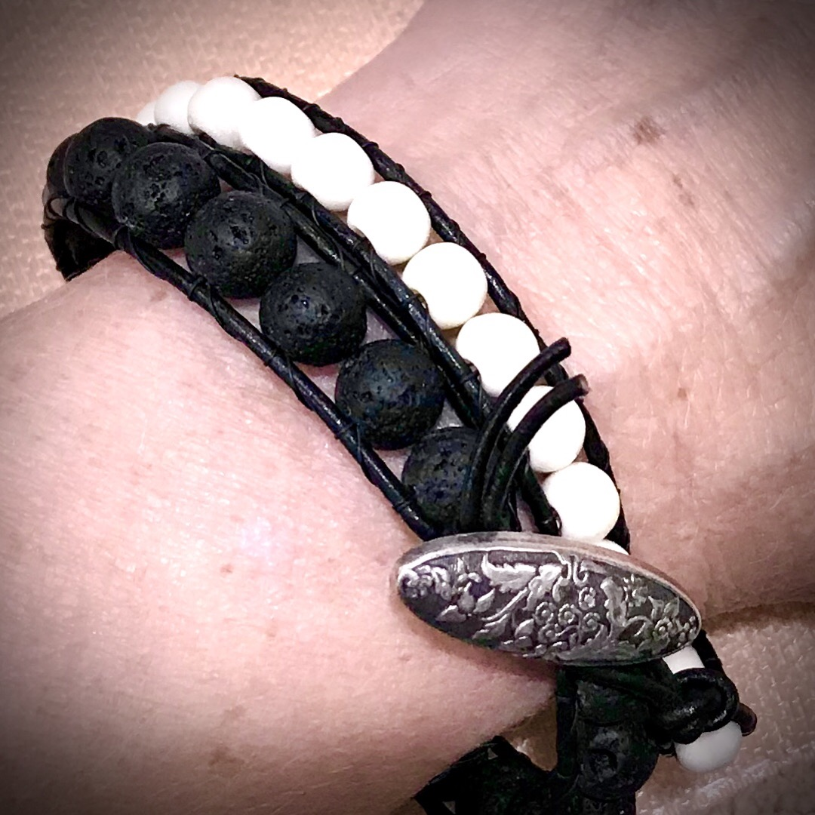
Double Wrap Bracelet! Artist: Kristin
Get tied up with Kristin and leave with your own handmade bracelet in this fun workshop! We will use a fire line and leather to encase lava beads and any other bead you choose into a long bracelet that wraps around your wrist at least twice. The lava beads are the perfect carrier for your favorite essential oil, such as peppermint, eucalyptus, etc. Great piece for people with metal sensitivities!
- Sunday, March 29
- 2:00 p.m. – 4:00 p.m.
- Class size: 10
- Ages: 16 and older
- Workshop fee: $40, payable at time of registration

Art Exploration! Free! Free! Free!
Are you looking for camaraderie while exploring your artistic side? Join Gallery artist Pat Glick every Tuesday afternoon, 1 p.m. – 3 p.m. to explore different art techniques. Pat will lead you through a creative art experience every week. Feel free to bring something you are working on also. We will have opportunities to participate in community activities and charities at times.
Art Exploration is free so you just bring your willingness to try something new in art!
- Every Tuesday
- 1:00 p.m. – 3:00 p.m.

ArtForms artists also offer pop-up workshops during the month. Follow the Gallery on its Facebook page and/or its website!
- Facebook: https://www.facebook.com/ArtFormsGallery620/
- Website: www.artforms-gallery.com

Do you have a birthday or special occasion to celebrate? Contact the Gallery to book a private party with an ArtForms Gallery artist!
Possibilities include:
- Sip and Paint  - Painting  - Jewelry  - Textiles | - Fused Glass/Stained Glass  - Pottery (ceramic birdhouse, windchime, pitchers, wheel-throwing)  - Woodcarving
Have a workshop suggestion or special request for us?
Don’t hesitate to give us a call!


Become a
Gallery Patron
Save 10% on every workshop you take in a 12-month period!!!
Only $40.00


Give the gift of creativity with an ArtForms Gallery Gift Card or a Gallery Patron Membership!

