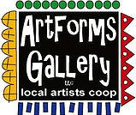
March 2023 Workshops
620 N. Broadway, Pittsburg, KS 620-240-0165
ArtForms Gallery is a co-op of artists offering monthly workshops ranging from acrylic painting, watercolor, oil pastels, glass fusing, pottery, metalsmithing, jewelry, textiles, kids’ art and more! All workshops are held at the Gallery unless otherwise noted. Please call Artforms Gallery to register for any artist’s workshop. 620-240-0165
Refunds/Cancellations—Decisions regarding refunds and cancellations are determined by the artist leading the workshop. You can find individual contact information for each artist on the “Artists” page of our website, or just call the Gallery and we’ll get you in touch. Facebook:ArtFormsGallery620/
Art Explorations!
Are you looking for camaraderie while exploring your artistic side? Join Gallery artists Pat Glick every Tuesday afternoon for a fun time working on your own project or art! Bring your materials and create with us for free!
Every Tuesday
March 7, 14, 21, 28
12:30 – 2:30 p.m.
FREE~FREE~FREE!!!
Give the Gift of Art
- Original Art
- Local Artists
- Gift Cards

Gift cards may be purchased in any amount and do not expire. They may be redeemed for workshops or for original art!

To check the balance of your Gift Card online:
https://squareup.com/gift/46K96BF2TK6W7/check-balance
Website:www.artforms-gallery.com

Pisces Zodiac Painting Artist: Lacy Warfel
The month of March includes the “last” sign in the zodiac, Pisces. Those born under this sign are known for their imagination…so let it run rampant in this small acrylic make and take workshop!
- Date: Wed, March 1 | 5:00 p.m. -- 7:00 p.m.
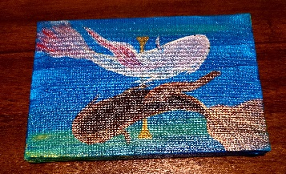
- Workshop fee: $25, due at time of registration
- Class Limit: 10
- Ages: 14 and older

Octopus Hug Painting Artist: Lacy Warfel
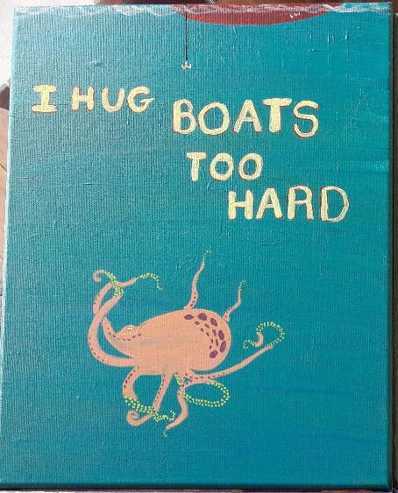
This Octopus, Inky Tuscadero, is lamenting hugging boats too hard. This is an easy beginner level painting that can become as complex as you want it to be. Underwater paintings are a blast! This is a small acrylic make and take.
- Date: Thurs, March 2 | 5:00 – 7:00 p.m.
- Workshop fee: $25, due at time of registration
- Ages: 14 and older
- Class limit: 10

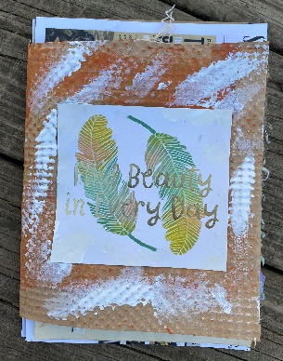
From Junk Mail to Junk Journal! Artist: Brenda Hayes
Turn your junk mail into an art journal! With paint, stencils, stamps, marking tools, and tapes, we will make an artsy journal with very affordable materials.

All materials will be provided, including some of my own junk mail. You are welcome to bring your own junk mail, envelopes, flyers, etc. to class to use.
- Date: Saturday, March 4 | 1:00 p.m. – 3:00 p.m.
- Workshop fee: $35.00, due at time of registration
- Ages: 13 and older
- Class size: Max 6

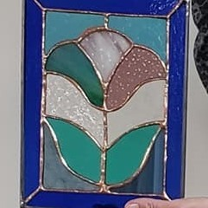
Beginning Stained Glass Artist: Dianne Miller
This 12-15 hour course is for the beginning stained glass art student or for someone who wishes to improve stained glass skills. You will learn to score, break, groze, grind, copper foil and solder your creation. You will take home a completed stained glass panel (approximately 8” x 10”) that you will be proud to display! An emphasis will be placed on glass considerations for different patterns, glass-cutting techniques and the steps to assemble a Tiffany-style glass panel. The in-depth instruction and handouts will get you started on your own stained glass journey at home if you desire to pursue the copper foil method in the future.
In a fun and relaxed atmosphere for learning, there will be demos, handouts, skills practice and plenty of time for questions. No experience is necessary. All tools, glass, and supplies will be provided by the instructor.
Protective eyewear is required. Regular eyeglasses are sufficient. Please do not wear open-toed shoes when working with glass! Class is limited to the first 8 participants who pay.
- Sundays, March 5, 12, 19, 26, April 2 (if needed)
- 1:30 p.m. to 4:30 p.m.
- $150, due at time of registration to guarantee a seat
- Ages 18 and older
- Minimum of 4 students required to hold the workshop; maximum 8 students
(Sample picture above is representative of a project. You will have a choice of 6 patterns.)

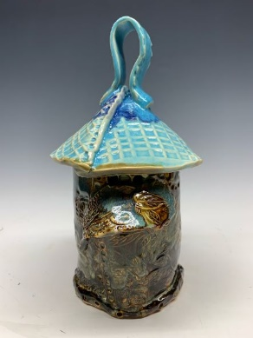
Ceramic Birdhouse ` Artist: Daria Claiborne
Time to make a home for your feathered friends. Create your own hand-built ceramic birdhouse just in time for spring! All supplies and kiln-firings are included.
- Date: Saturday, March 11 | 1:00 – 3:00 p.m.
- Workshop fee: $45, due at time of registration
- Ages 10 and up.
- Class size: 12 people

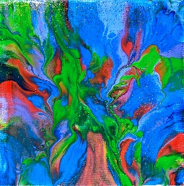
Mardi Gras Paint Party!! Artist: Debbie Southard
Get out your Mardi Gras beads and join in a pour painting Mardi Gras party! We will be having king cake and whoever gets the " baby" will receive a gift bag. We will be dipping our canvas and creating a unique painting. Everything you need is supplied. Come for the fun and create a lovely work of art.
- Saturday, March 18 | 2:00 – 4:00 p.m.
- Workshop fee: $35, due at time of registration
- Ages: 14 and older
- Class size: 10 participants

Cetus Zodiac Painting Artist: Lacy Warfel
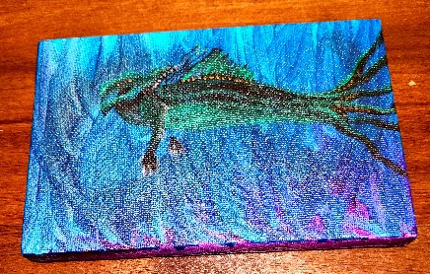
This is a small acrylic make and take. So you think you are a Pisces or Aries, huh? Think again! As noted by NASA, there is a new (old) 1st astrological sun sign. Cetus is for March 21-28th, a mere 7 days. Cetus is known to be a combo of Pisces and Aries traits with a dash of destruction and rebirth…
- Date: Tuesday March 21 | 5 PM—7 PM
- Workshop fee: $25, due at time of registration
- Ages: 14 and older
- Class limit: 10

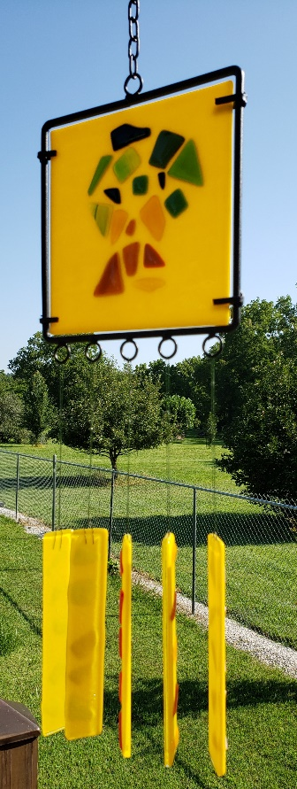
Fused Glass Windchimes! Artist: Dianne Miller
March winds bring April showers before we can have May flowers! Let’s make fused glass windchimes. Basic glass-cutting skills will be demonstrated, so no experience is necessary. You will create your chime using a variety of glass colors and shapes. Bring your creativity, and please wear close-toed shoes. After fusing in a glass kiln, your glass suncatchers will be available for pickup Thursday, March 30, at the Gallery.
- Date: Sat., March 25 | 1:00 p.m. -- 4:00 p.m.
- Workshop fee: $50, due at time of registration
- Class size: 10
- Ages: 12 and older
- Glass windchimes will not withstand strong winds.

Aries Zodiac Painting Artist: Lacy Warfel
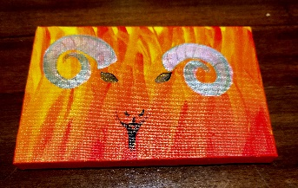
This is a small acrylic make and take. Aries is now the 2nd astrological sun sign. Aries are known for being relentless and fearless…
- Tuesday, March 28 | 5 PM--7PM
- Workshop fee: $25, due at time of registration
- Class Limit: 10
- Ages: 14 and older

ArtForms artists also offer pop-up workshops during the month. Follow the Gallery on our Facebook page and/or our website!

Facebook: ArtFormsGallery620/
Website: www.artforms-gallery.com

Do you have a birthday or special occasion to celebrate? Contact the Gallery to book a private party with an ArtForms Gallery artist!
Possibilities include:
- Sip and Paint  - Painting  - Jewelry  - Textiles  - Pour Painting | - Fused Glass/Stained Glass  - Pottery (ceramic birdhouse, windchime, pitchers)  - Fiber  - Glass and Resin
Have a workshop suggestion or special request for us?
Don’t hesitate to give us a call!

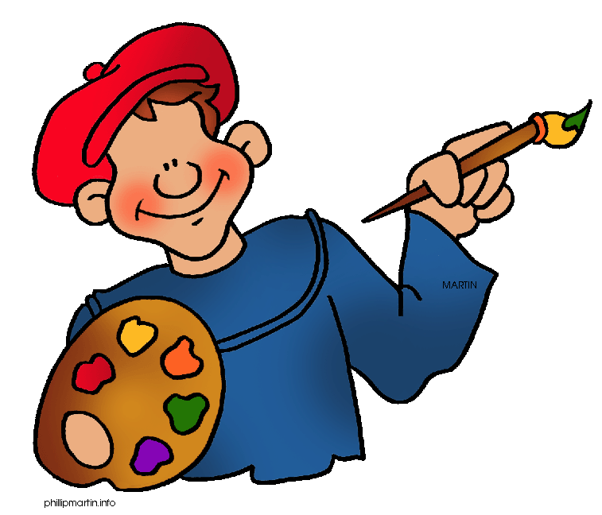
Become a
Gallery Patron
Save 10% on every workshop you take in a 12-month period!!!
Only $40.00

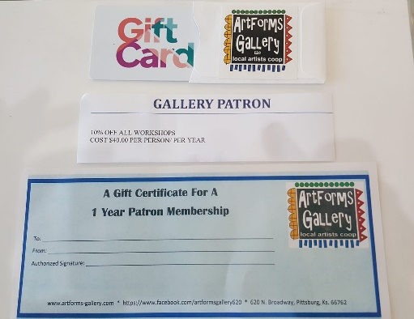
An ArtForms Gallery gift card makes the perfect gift for any occasion! Our gift cards may be purchased in any amount and they never expire.

