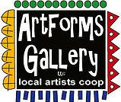**December 2022 Workshops**

**620 N. Broadway, Pittsburg, KS 620-240-0165**

**Holiday Open House**

**Friday, December 2**

**5:00 – 8:00 p.m.**

ArtForms Gallery is a co-op of artists offering monthly workshops ranging from acrylic painting, watercolor, glass fusing, pottery, metalsmithing, jewelry, textiles, kids’ art and more! All workshops are held at the Gallery unless otherwise noted. Please call Artforms Gallery to register for any artist’s workshop. **620-240-0165**

**Refunds/Cancellations—Decisions regarding refunds and cancellations are determined by the artist leading the workshop.** You can find individual contact information for each artist on the “Artists” page of our website, or just call the Gallery and we’ll get you in touch.

**Give the Gift of Art**

* Original Art
* Local Artists
* Gift Cards

Gift cards may be purchased in any amount and do not expire. They may be redeemed for workshops or for original art!

To check the balance of your Gift Card online:

[https://squareup.com/gift/46K96BF2TK6W7/check-balance](https://squareup.com/gift/46K96BF2TK6W7/check-balance?fbclid=IwAR1iEqUd4ASMldq6Fm8eoysfMKfOYcFHXH1Rb1SFKIGHspD2yyCQCQInoJ8)

Website: [www.artforms-gallery.com](http://www.artforms-gallery.com)

Facebook: [ArtFormsGallery620/](https://www.facebook.com/ArtFormsGallery620/)

Each month Gallery artists design and design and stage our front window for your viewing pleasure!

Beginning in mid-November, Brenda Hayes will stage another creative Gallery window. We hope you enjoy it!

**Meet our newest artist: Lacy Warfel**

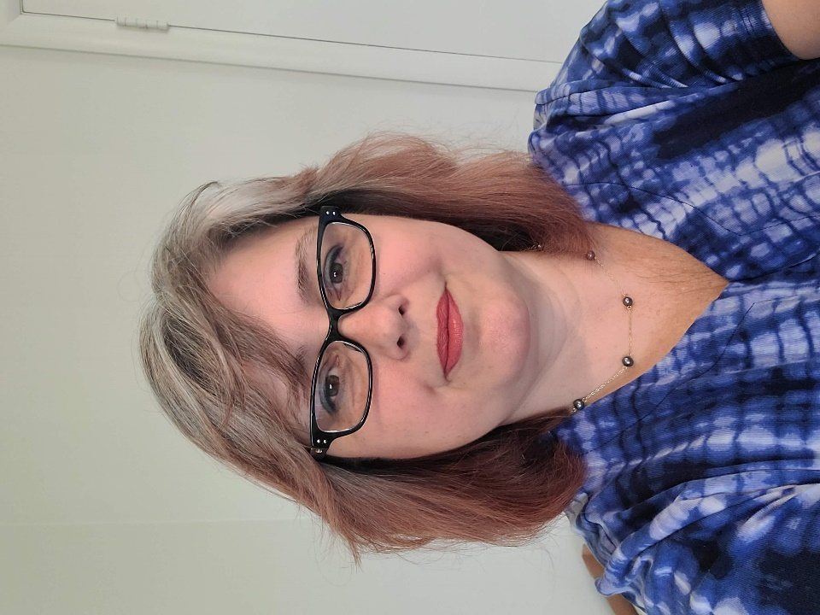I have drawn from my early creative endeavors as a professional belly dancer and circus performer to recreate a sense of whimsy and wonder in my work. One thing I learned over the years is that we all crave the same emotional experiences that can be conveyed through the arts. The sense of abandonment of a half sunken boat or the awe of an improbably colored sunrise are examples of that emotional connection. I am fascinated with portals, paths, and water as a means to carry a viewer away from the mundane world into someplace beautiful and sometimes mystical. I am a big fan of adventures and paintings are a way to take others with me.

Recently, I have found a happy marriage between my left brained chemist side and my always-on creative right brain. Acrylic paint pouring is modern-day alchemy! I am so excited to continue to explore ways to create something beautiful out of specific gravities and the repelling qualities of oil and water.

Artist and Retired Performer

Art Explorations is temporarily not offered. We hope to get it back on the schedule soon.

**Icy Winter Night Credit Card Painting** **Artist: Lacy Warfel**

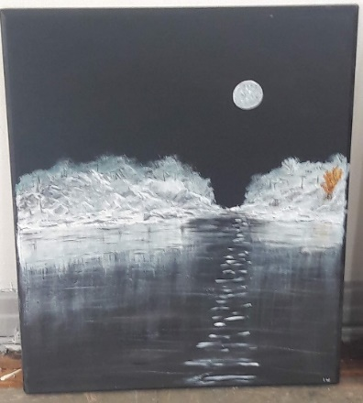This is an easy, beginner level make & take. Bring an old credit card, library card, grocery club card- whatever you have. This painting goes fast, but you’ll have plenty of time to finish. This will be a smaller sized canvas.

* Sunday, December 4 | 3:00 – 5:00 p.m.
* Fee: $30, payable at registration
* Ages: 14 and older
* Class limit: 10

**Kids Paint Party! Artist: Nicole Meyer-Foresman**

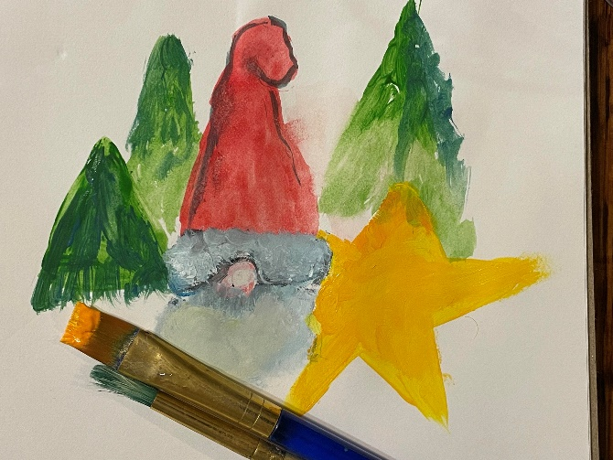Holiday themed paint party for young artists!   Children will create a one of kind holiday masterpiece using acrylic paint and embellishments. Painting techniques will be taught; however, emphasis will be on enhancing creativity through personal expression.  Hot cocoa and cookies will be served!

* Saturday, December 10 | 10:00 - 11:30 a.m.
* Workshop fee: $25, payable at registration
* Age Group: 6 – 11 years

**Teen Paint Party Artist: Nicole Meyer-Foresman**

This workshop is designed for young artists who love to paint and would like to improve their skills.  A variety of materials will be provided, but students will choose their own content.  Art sessions decrease stress while creative decision-making increases problem-solving skills. This opportunity is a win-win!

* Saturday, December 10 | 1:00 – 3:00 p.m.
* Workshop fee: $30, payable at registration
* Age group: 12 – 17 years

**Paint & Sip! Artist: Nicole Meyer-Foresman**

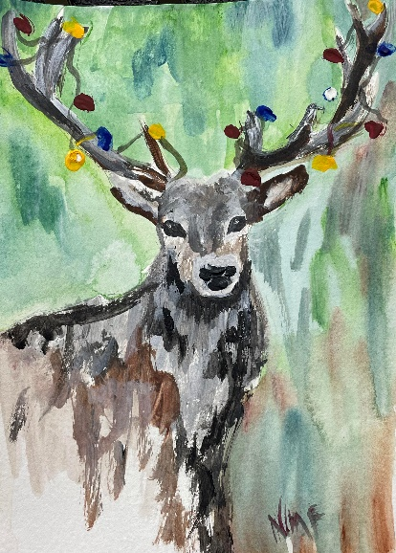Whether you are a veteran artist or it's been years since you've held a paintbrush, plan for a Saturday evening of 'feel good' painting. Drawing skills are not required for this loose technique as we will use a Reindeer silhouette, and then fill in with color scheme of your choice.  Acrylic paint on a 16” x 20” stretched canvas.

Bring your own beverage* and prepare to have a good time!

* Saturday, December 10 | 5:00 – 7:00 p.m.
* Workshop fee: $40
* Class limit: 12
* Ages: *21 to bring alcohol

Relax with a loose painting style for the holidays!

**Poured Ornaments**  Artist: Debbie Southard

Let's pour some ornaments for your tree!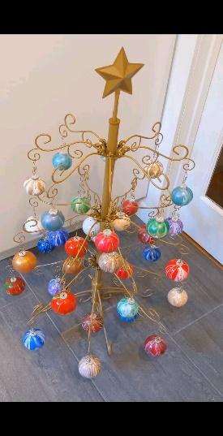 Fun and easy to

do🎄🎄🎄🎄🎄.

* Saturday, December 17 | 2:00 – 4:00 p.m.
* Fee: $35
* Ages: 14 and up
* Class size: 10

ArtForms artists also offer pop-up workshops during the month. Follow the Gallery on its Facebook page and/or its website!

Facebook: [ArtFormsGallery620/](https://www.facebook.com/ArtFormsGallery620/)

Website: [www.artforms-gallery.com](http://www.artforms-gallery.com)

Do you have a birthday or special occasion to celebrate? Contact the Gallery to book a private party with an ArtForms Gallery artist!

Possibilities include:

|  |  |
| --- | --- |
| * Sip and Paint * Painting * Jewelry * Textiles | * Fused Glass/Stained Glass * Pottery (ceramic birdhouse, windchime, pitchers) * Fiber |
| **Have a workshop suggestion or special request for us?**  **Don’t hesitate to give us a call!**  See the source image  **Become a**  **Gallery Patron**  Save 10% on **every** workshop you take in a 12-month period!!!  Only $40.00 | |

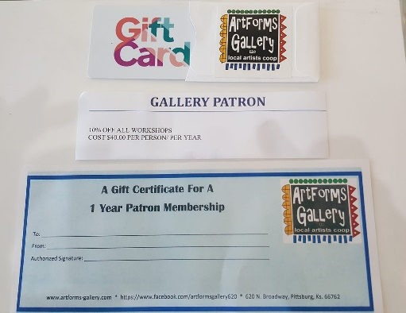ArtForms Gallery has the perfect gift for any occasion! Our gift cards may be purchased in any amount.