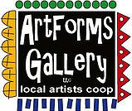**September 2022 Workshops**

**620 N. Broadway, Pittsburg, KS 620-240-0165**

ArtForms Gallery is a co-op of artists offering monthly workshops ranging from acrylic painting, watercolor, glass fusing, pottery, metalsmithing, jewelry, textiles, kids’ art and more! All workshops are held at the Gallery unless otherwise noted. Please call Artforms Gallery to register for any artist’s workshop.

**620-240-0165**

Refunds/Cancellations—Decisions regarding refunds and cancellations are determined by the artist leading the workshop. You can find individual contact information for each artist on the “Artists” page of our website, or just call the Gallery and we’ll get you in touch.

Website: [www.artforms-gallery.com](http://www.artforms-gallery.com)

**Give the Gift of Art**

* Original Art
* Local Artists
* Gift Cards

Gift cards may be purchased in any amount and do not expire. They may be redeemed for workshops or for original art!

To check the balance of your Gift Card online:

[https://squareup.com/gift/46K96BF2TK6W7/check-balance](https://squareup.com/gift/46K96BF2TK6W7/check-balance?fbclid=IwAR1iEqUd4ASMldq6Fm8eoysfMKfOYcFHXH1Rb1SFKIGHspD2yyCQCQInoJ8)

Facebook: [ArtFormsGallery620/](https://www.facebook.com/ArtFormsGallery620/)

Each month Gallery artists design and design and stage our front window for your viewing pleasure!

The August window display is courtesy of Janet Lewis and Jim Miller. We hope you enjoy it!

**Don’t forget that the Red, White, and Blue flags below our window outside are for sale at $25!**

.

**Art Exploration/Weekly Beginning Painting Instruction**

**Artist: Pat Glick**

Are you looking for camaraderie while exploring your artistic side? Join Gallery artist Pat Glick **every** Tuesday afternoon for a fun time working on your own project or art! Bring your materials and create with us for free!

* Tuesdays, September 6, 13, 20, 27 | 12:30 – 2:30 p.m.
* Art Exploration Workshop Fee: FREE~FREE~FREE!!!
* Beginning Painting Workshop Fee: $15 per session, payable at time of registration each week to reserve a spot
* Ages: Adults only

**Fused Glass Pocket Vase** Artist: Dianne Miller

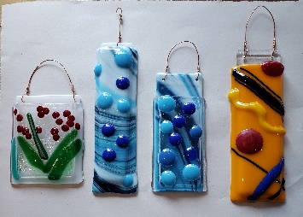Create 3 pocket vases to keep or give as gifts! You will create a design by arranging cut pieces of glass and adorable embellishments on a white glass base. Special ceramic paper will be sandwiched between your glass design layer and a clear base ready to fire in the kiln. The result is a pocket vase that actually holds water! Basic glass-cutting skills are taught so experience is not required. Just bring your enthusiasm and creativity! All supplies, tools, instructions, and kiln-firing are included in the workshop fee. Please wear close-toed shoes when working with glass. Protective eyewear is available if you do not wear glasses or you may bring your own.

* Date: Saturday, September 10 | 10:00 a.m. – 1:00 p.m.
* Fee: $45, payable at time of registration
* Class limit: 10
* Age: 14 years and older

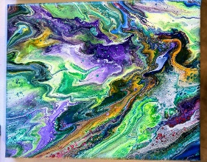**Hot town, summer in the city  
Back of my neck getting dirty and gritty...**

**The Lovin' Spoonful...”Summer in the City”**

**Hot Dirty Pour! Artist: Debbie Southard**

In this workshop, we are going to do a technique called a “Dirty Pour”, but your neck should not get dirty and gritty!! All supplies and instruction are provided for those who have no experience or lots of experience. Once varnished, your art is very touchable and can be wiped off easily with a damp cloth to clean.

* Date: Saturday, September 17 | 2:00 p.m. – 4:00 p.m.
* Fee: $35, payable at time of registration
* Class limit: 10
* Age: 14 years and older

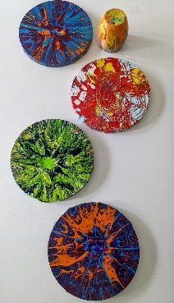**Spin Art Returns to ArtWalk** **Artist: Debbie Southard**

Come join this class to be held in front of ArtForms Gallery during Art Walk! If you want to have some fun and spin some art join us at Art Forms Gallery. This is a Come and go event. Participants must pick up painting the next week due to wet paint.

All supplies and instruction are provided for those who have no experience or lots of experience. Once varnished, your art is very touchable and can be wiped off easily with a damp cloth to clean.

* Date: Friday, September 23 | 5:00 p.m. – 8:00 p.m.
* Fee: $20, payable at ArtWalk inside ArtForms Gallery
* Age: Children must be accompanied by an adult.

**Upcycyled Sweater Hats! Artist: Brenda Hayes**

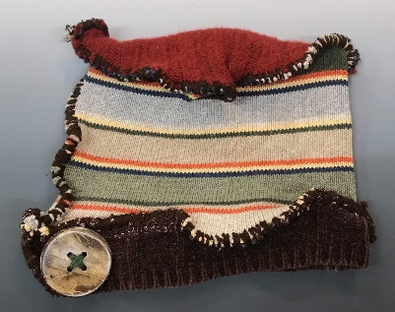It may be 100 degrees in the Four-State area right now, but the Farmer’s Almanac says, THE WINTER FORECAST MAP CARRIES JUST FIVE WORDS FLOATING THE MIDWEST: “HIBERNATION ZONE, GLACIAL, SNOW-FILLED.” THE PUBLICATION IS CALLING FOR AN EXCEPTIONALLY SNOWY, EXTREMELY COLD WINTER FOR 2022-2023.

So let’s be ready! Join Brenda in taking old sweaters and making funky, upcycled hats to be prepared for the winter in style! Materials including embellishments, sweaters, and tools are supplied.

* Date: Saturday, September 24 | 2:00 p.m. – 4:00 p.m.
* Fee: $35, payable at time of registration
* Class limit: 6
* Age: 14 years and older

New Workshop Offering!!!

**Easy Cricut Halloween Artist: Phil Dellasega**

Learn the basics of using the Cricut vinyl cutter. In this class, you'll learn how to assemble a design for heat transfer vinyl in Design Space, the Cricut cutting software. You'll cut the design, weed it, and learn how to transfer it to a supplied canvas tote using supplies you have in your home. If you'd prefer to apply it to a garment, you can bring one to the workshop.

If you have a laptop, feel free to bring it. We can upload the software for you to use during the class. Everyone in the class will have access to all the designs, whether you use your computer or ours.

* Date: September 28 | 6:00 p.m. -8:30 p.m.
* Fee: $40 per person
* Minimum age: 14
* Class Limit: 8

**Check our Facebook page during the month as artists may offer “popup” workshops!**

ArtForms artists also offer pop-up workshops during the month. Follow the Gallery on its Facebook page and/or its website!

* Facebook: [ArtFormsGallery620/](https://www.facebook.com/ArtFormsGallery620/)
* Website: [www.artforms-gallery.com](http://www.artforms-gallery.com)

Do you have a birthday or special occasion to celebrate? Contact the Gallery to book a private party with an ArtForms Gallery artist!

Possibilities include:

|  |  |
| --- | --- |
| * Sip and Paint * Painting * Jewelry * Textiles | * Fused Glass/Stained Glass * Pottery (ceramic birdhouse, windchime, pitchers) * Fiber |
| **Have a workshop suggestion or special request for us?**  **Don’t hesitate to give us a call!**  See the source image  **Become a**  **Gallery Patron**  Save 10% on **every** workshop you take in a 12-month period!!!  Only $40.00 | |

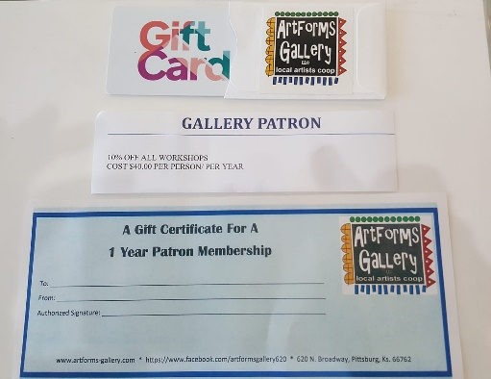

Give the gift of creativity with an

ArtForms Gallery Gift Card or a

Gallery Patron Membership!