
June 2021 Workshops
620 N. Broadway, Pittsburg, KS 620-240-0165

ArtForms Gallery artists love when you visit our Gallery in search of the unique, handmade gift or a new art piece for your home or office! However, we also want our customers and artists to remain safe during the changing health conditions in our community. Please maintain appropriate social distancing and wear a mask when visiting. We will do our part in maintaining a clean and safe environment for you to shop or take a workshop. We look forward to seeing you soon!

ArtForms Gallery is a co-op of 18 different artists offering monthly workshops ranging from oil painting, watercolor, glass fusing, pottery, wood carving, metalsmithing, jewelry, textiles, kids’ art and more! All workshops are held at the Gallery unless otherwise noted. Please call Artforms Gallery to register for any artist’s workshop. 620-240-0165

Refunds/Cancellations—Decisions regarding refunds and cancellations are determined by the artist leading the workshop. You can find individual contact information for each artist on the “Artists” page of our website, or just call the Gallery and we’ll get you in touch.

Website: www.artforms-gallery.com
Facebook: ArtFormsGallery620/
Mother’s Day and Father’s Day are soon and these workshops make a great gift to the Mom and Dad in your life! ArtForms Gallery also offers gift cards in any amount.

Art Exploration! Free! Free! Free!
Are you looking for camaraderie while exploring your artistic side? Join Gallery artists Pat Glick and Laura Wright every Tuesday afternoon to explore different art techniques. Pat and Laura will lead you through a creative art experience every week. Feel free to bring something you are working on also. We will have opportunities to participate in community activities and charities at times.
Art Exploration is free so you just bring your willingness to try something new in art!
- Tuesdays, June 8, 15, 22, 29 | 1:00 -3:00 p.m.
- Workshop Fee: FREE~FREE~FREE!!!

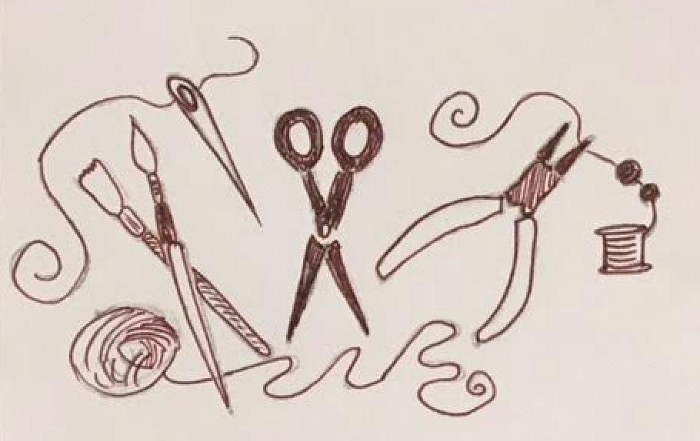
Instructors: Kristin Girard and Nicole Meyer-Foresman
We are excited to announce this year’s activities will feature ‘Art to Wear’! Working with a range of materials, participants will learn to design, stitch, fabricate and embellish!

Space is limited, so reserve a spot now! Masks are required to be worn in the Gallery.

- June 1- 4, 2021 (Tuesday - Friday)
- Ages: 6 - 9 yrs old | 9:00 a.m. – 10:00 a.m.
- Ages: 10 - 12 yrs old | 11:00 a.m. – 12:30 p.m.
- Ages: 13 - 17 yrs old | 1:30 p.m. – 3:00 p.m.
- Workshop fee: $50 per student, payable at time of registration
- Class size: 10 max
Questions? Contact Nicole: nmeyer@girard248.org

Soak & Stoke’ | A mini jewelry making bootcamp for adults!
Instructors: Kristin Girard and Nicole Meyer-Foresman
Learn two jewelry making techniques that are sure to spice up your (art making) toolbox. This unique multi-session workshop will feature Kristin and her amazing electroforming with organics technique, and Nicole torching it up with solder to create sterling wire jewelry.
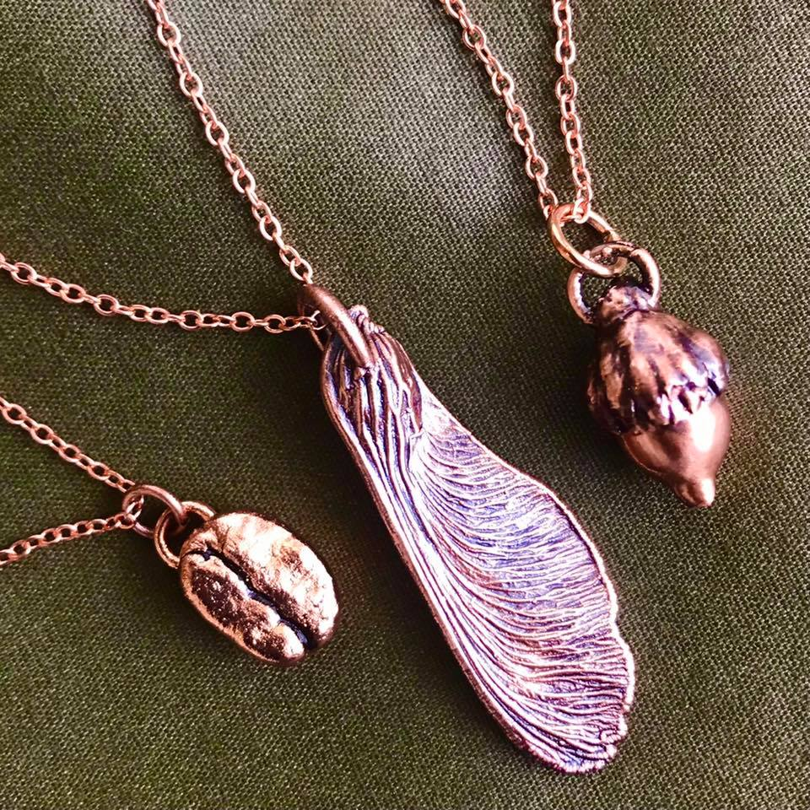
- Electroforming with Kristin
  - June 1 | 4:00 – 5:00 p.m.
  - June 3 | 4:00 – 6:00 p.m.
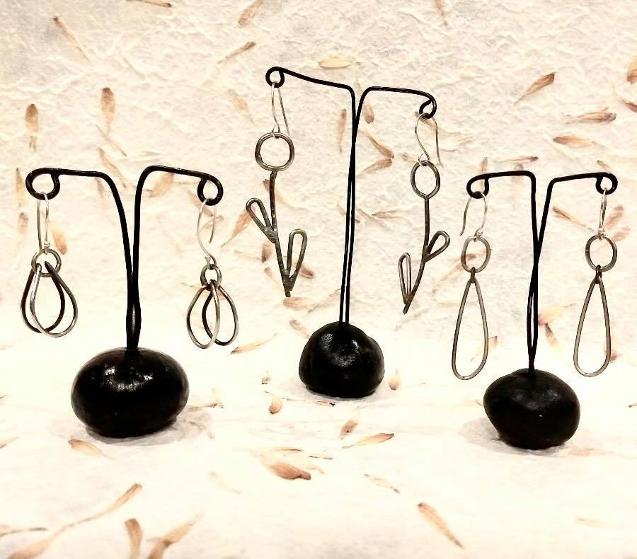
- Silver Solder with Nicole
  - June 1 | 5:00 – 6:00 p.m.
  - June 2 | 4:00 – 6:00 p.m.
- Workshop fee: $90 for all 3 sessions; $50 for just one technique
- Class size: 8 adults
- If you register for just one technique, please specify which technique.

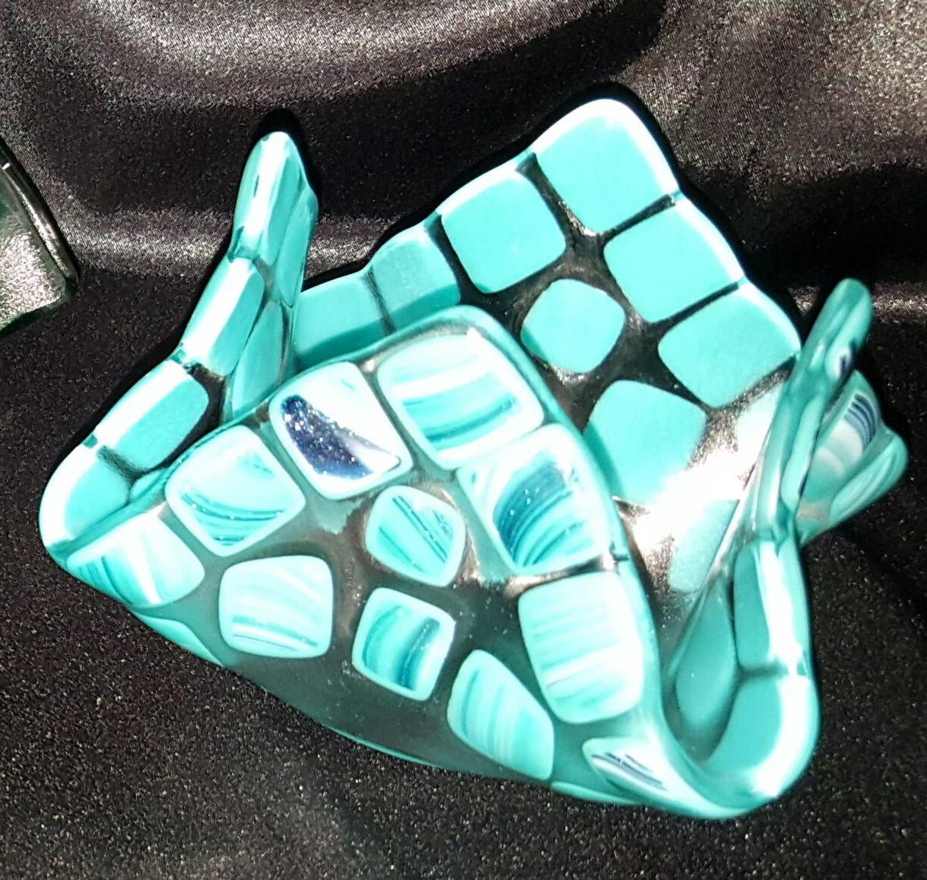
Fused Glass Votive Cups Artist: Dianne Miller
Glass votive cups make great gifts! Votive cups are suitable to be used for jelly/butter dishes or hold candies and nuts. Another use is to burn a small votive candle inside to add a glow to your evenings. Create an adorable votive cup by arranging cut pieces of glass on a 6” clear glass base. Basic glass-cutting skills are taught so experience is not required. Just bring your enthusiasm and creativity! All supplies, tools, and instructions are included in the workshop fee. Please wear close-toed shoes when working with glass. A mask is required while in the Gallery. Protective eyewear is available if you do not wear glasses or bring your own.
- Saturday, June 5 | 1:00 p.m. - 4:00 p.m.
- Ages 14 and older
- Class is limited to 10
- Workshop Fee: $30; payable at time of registration

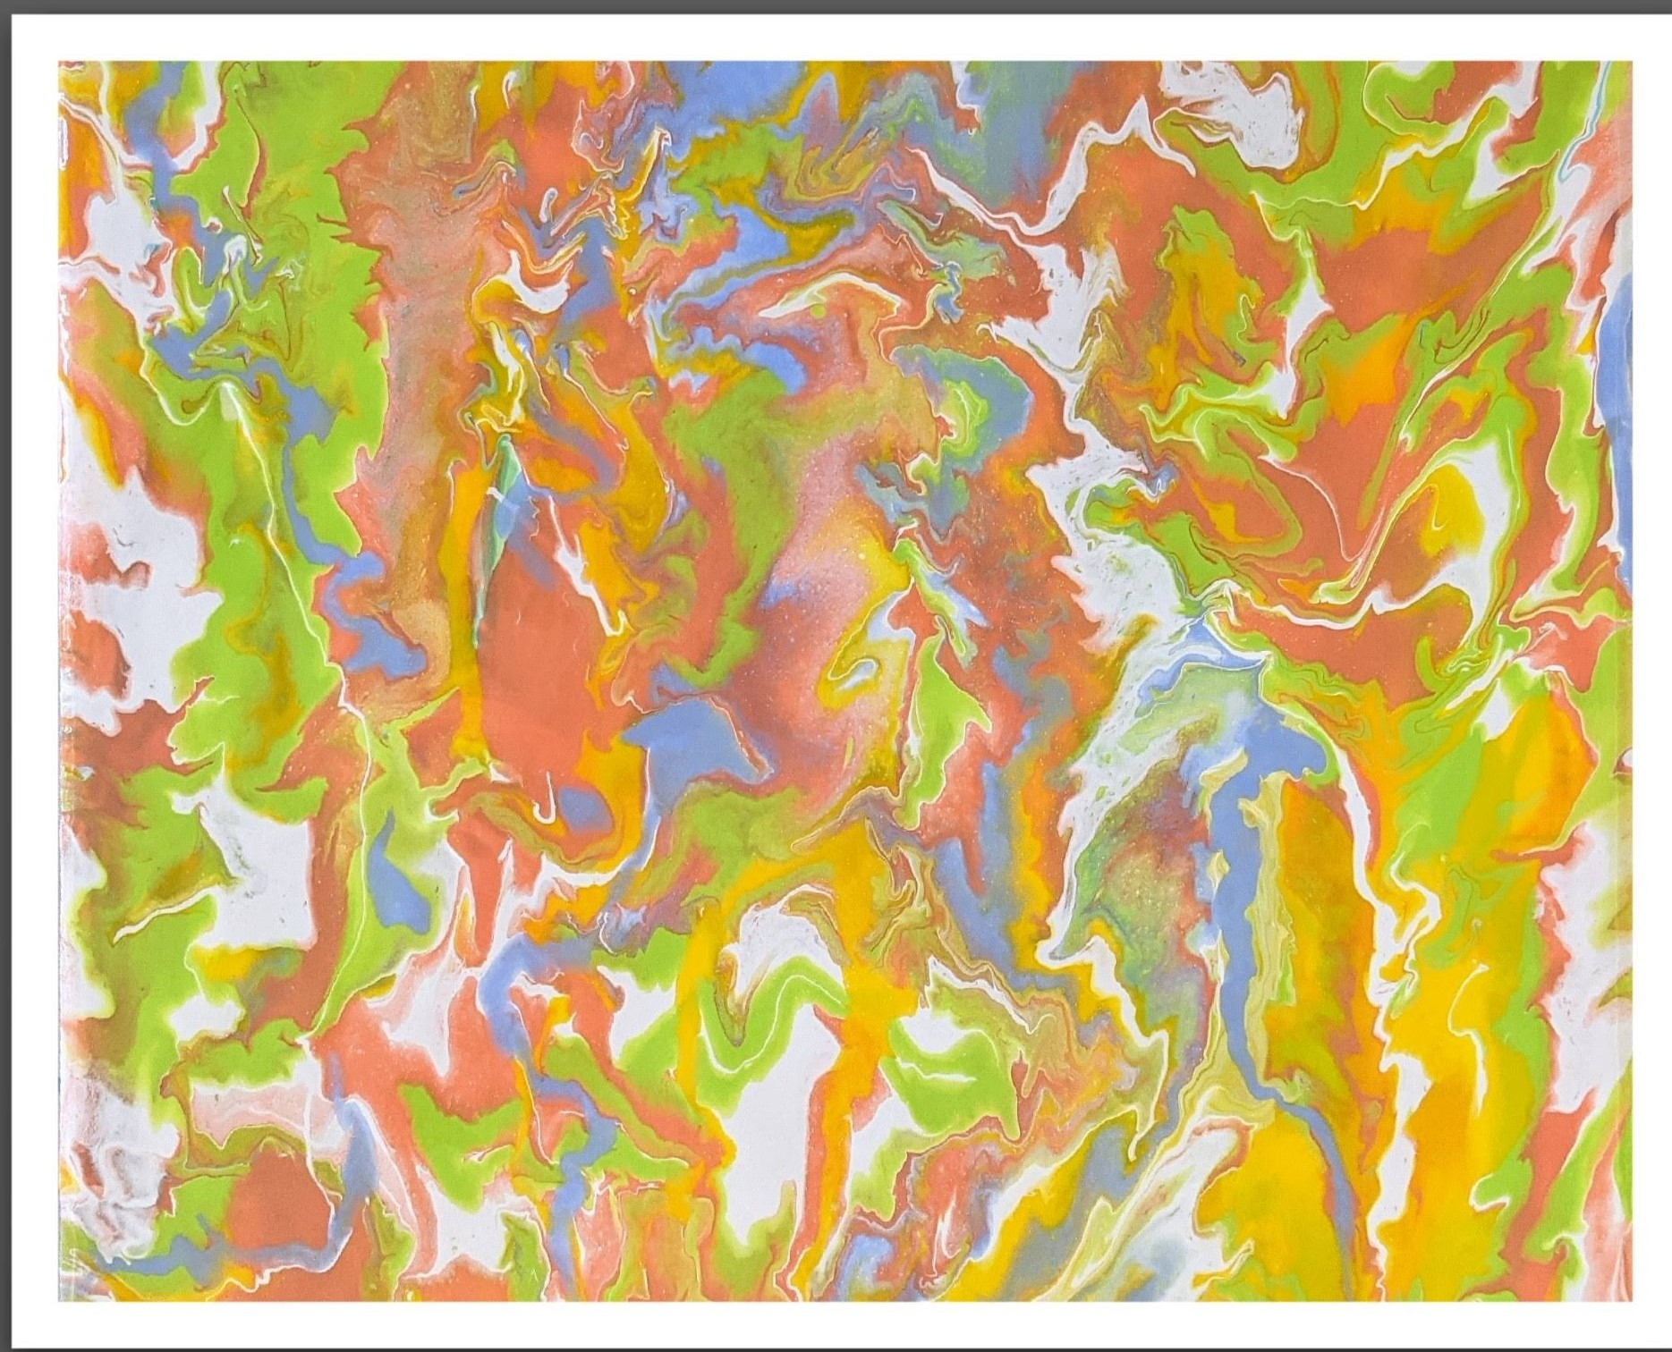
Pour Painting Artist: Debbie Southard
School is out for summer! Flip cup or flop cup? Which will it be? You make the choice! Let’s have a blast flipping and flopping paint on the canvas. All materials are supplied. Come ready for some fun with paint!
- Saturday, June 12 | 2:00 p.m. – 4:00 p.m.
- Workshop fee: $40, payable at registration
- Ages: 10 years and older
- Class size: minimum 4; maximum 10

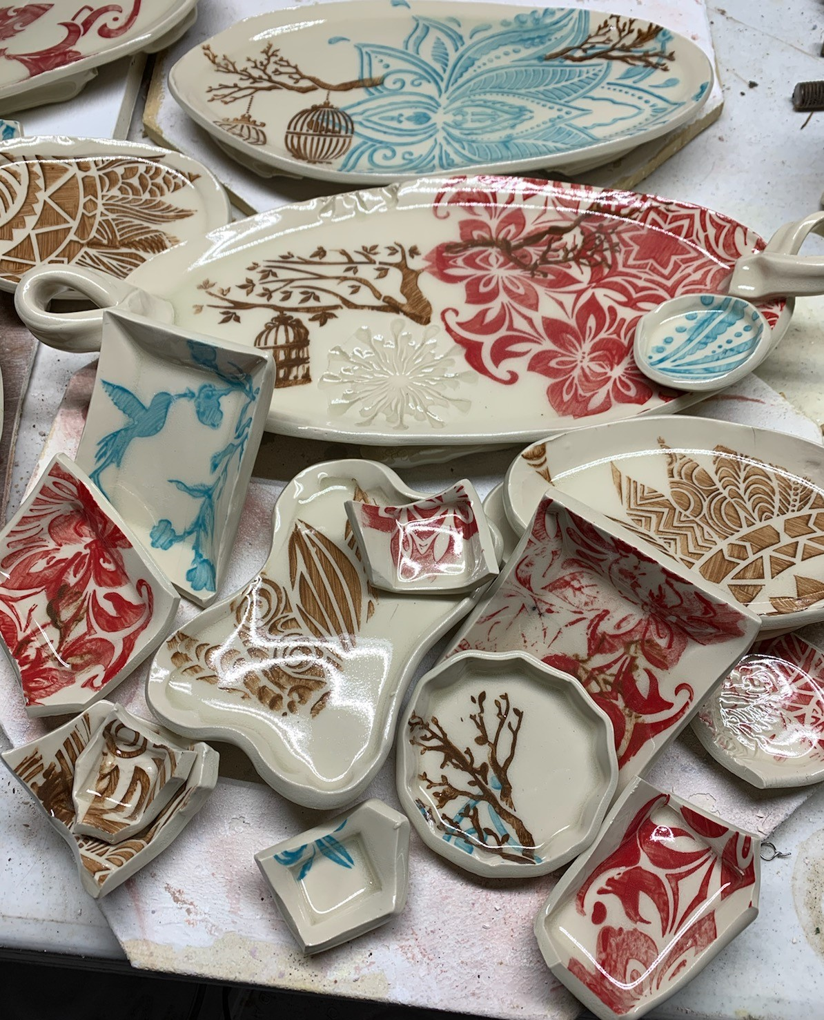
Stenciled Ceramic Trays Artist: Daria Claiborne
You will work with a slab of clay and underglazes along with your choice of a stencil (or combine two stencils with contrasting colors). They will "magically" be transformed into rimmed trays! All supplies are included. Masks are required in the Gallery.
- Sunday, June 13 | 2:00 p.m. – 4 p.m.
- Ages: 12 and up. Parental supervision for those 12-14.
- Class size: 8 Masks are required.
- Workshop fee: $45, payable at time of registration

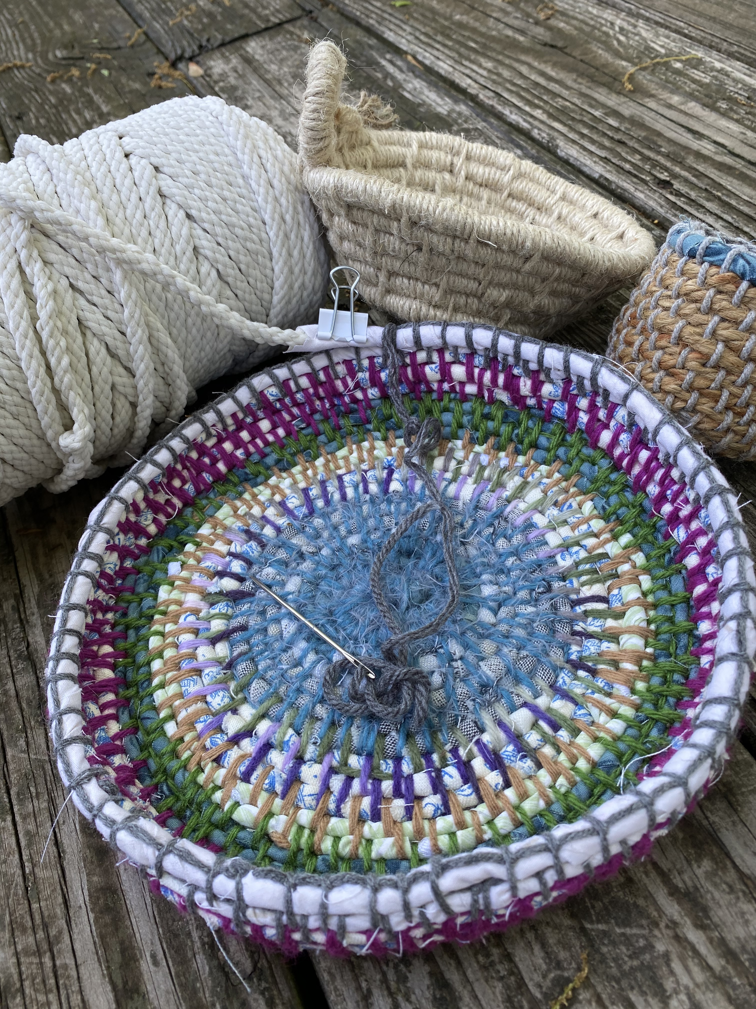
Coil Basketry Basics Artist: Brenda Hayes
We will make a coiled basket using various materials. The basic principle of coil basketry is that one long fiber is wrapped around others fibers and stitched in place to create coils. All materials will be provided.

- Saturday, June 26 | 1:00 p.m. – 4:00 p.m.
- Ages 16 and older
- Class size: 8 participants
- Workshop fee: $35, payable at time of registration

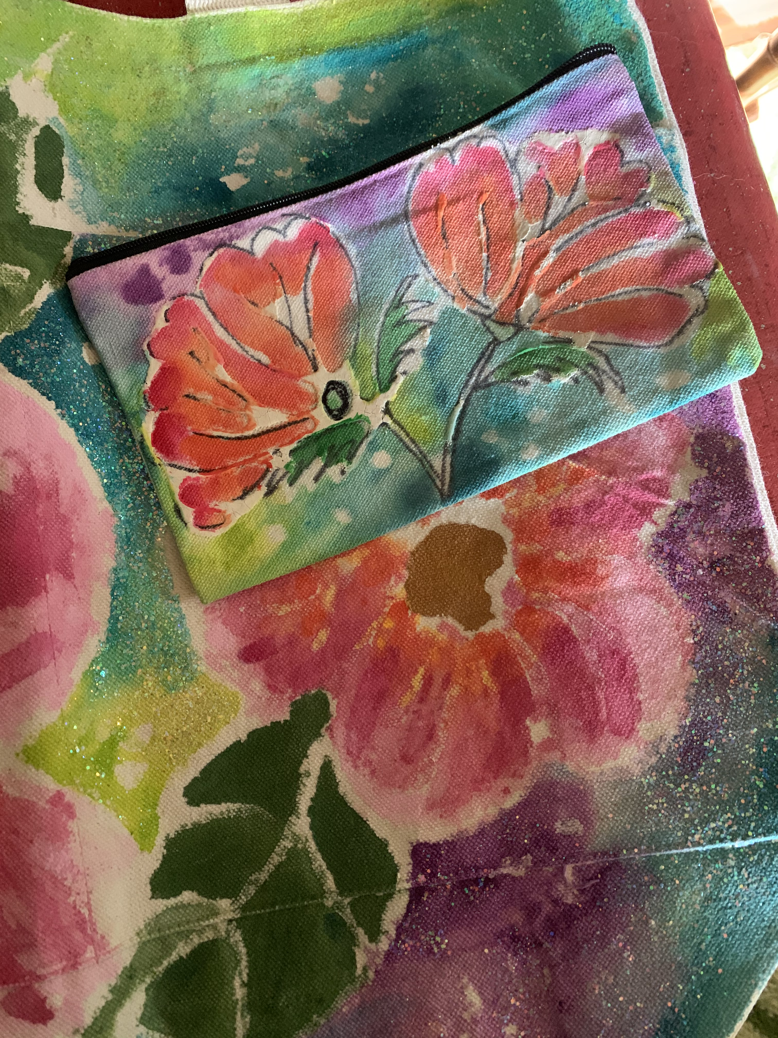
Batik canvas bags Artist: Daria Claiborne
Two sizes of bags will be decorated in a Zimbabwe style batik. Some acrylics will be available. If you want to bring additional colors or fabric paint, please do. Several hair dryers and heat guns will be on hand, but extra hair dryers would be great. Other supplies will be available to create your personalized bags. Masks are required to be worn in the Gallery.
- Sunday, June 27 | 2:00 p.m. – 4:00 p.m.
- Ages 12 and up. Parental supervision required for those 12-14.
- Class size: Limited to 10 people.
- Workshop fee: $45, payable at time of registration

Check our Facebook page during the month as artists may offer “popup” workshops!
ArtForms artists also offer pop-up workshops during the month. Follow the Gallery on its Facebook page and/or its website!
- Facebook: ArtFormsGallery620/
- Website: www.artforms-gallery.com

Do you have a birthday or special occasion to celebrate? Contact the Gallery to book a private party with an ArtForms Gallery artist!
Possibilities include:
- Sip and Paint  - Painting  - Jewelry  - Textiles | - Fused Glass/Stained Glass  - Pottery (ceramic birdhouse, windchime, pitchers)  - Woodcarving  - Fiber
Have a workshop suggestion or special request for us?
Don’t hesitate to give us a call!


Become a
Gallery Patron
Save 10% on every workshop you take in a 12-month period!!!
Only $40.00


Give the gift of creativity with an
ArtForms Gallery Gift Card or a
Gallery Patron Membership!

